
Viewed by:
Philippe POHER
Tel.: +33 (0)2 99 27 92 92
E-mail: philippe.poher@iwedia.com

Written by:
Guy SCRUIGNEC
Tel.: +33 (0)2 99 27 92 92
E-mail: guy.scruignec@iwedia.com
IWEDIA

TDAL_NVM Technical Specifications

V2.0

Approved by:
Thierry GARNIER
Tel.: +33 (0)2 99 27 92 92
E-mail: thierry.garnier@iwedia.com

SUMMARY
1 Reference documents 3
2 Documentation History 4
3 Introduction 5
4 Module Overview and Architecture 6
4.1 Definitions, Acronyms and Abbreviations 6
4.2 General Description 7
4.3 Architecture 7
4.4 TDAL NVM API Description 8
5 TDAL_NVM API Specification 9
5.1 Type Specifications 9
5.2 TDAL_NVM API Usage 10
5.3 TDAL_NVM Macro/Define/Enum/Typedef/Structure Definitions 11
5.3.1 Enumeration Definitions 11
5.4 TDAL_NVM API Functions 12
5.4.1 TDAL_NVM_Init(-) 12
5.4.2 TDAL_NVM_Term(-) 12
5.4.3 TDAL_NVM_Open(-) 12
5.4.4 TDAL_NVM_Close(-) 13
5.4.5 TDAL_NVM_Read(-) 13
5.4.6 TDAL_NVM_Write(-) 14

Reference documents
The following documents were used to write this specification:

Document | Version | Title

Documentation History

History
Vers. | Date | Nature
0.1 | 23/08/2004 | initial version
1.0 | 24/08/2004 | Editorial review
1.1 | 17/02/2005 | ARV : changed implementation section
2.0 | 18/01/2008 | CHAL V2 API

Introduction
The purpose of this document is to specify the interface and to describe the internal design of the Thin Driver Adaptation Layer for Non Volatile Memory [TDAL_NVM]. The aim of this module is to provide a complete interface between middlewares and the non volatile memory stage low level driver of a set-top-box.

Module Overview and Architecture

Definitions, Acronyms and Abbreviations
API | Application Programmer’s Interface
TDAL | Thin Driver Adaptation Layer
NVM | Non Volatile Memory

General Description
The main job of the TDAL_NVM is to offer an area to the client to save information in non Volatile memory.
If EEPROM memory is present in the product, the TDAL_NVM must enable the client to have access to this memory. Else, the TDAL_NVM must offer the access to a specific area in flash memory, not accessible by TDAL_FLA.

Architecture
The figure below shows the relation between the client module and the low level drivers:
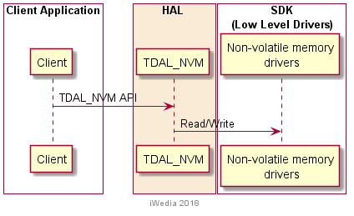

TDAL NVM API Description
The TDAL NVM API is described below:
TDAL_NVM_Init(): Initialize an instance of the NVM device driver
TDAL_NVM_Term(): Terminate an instance
TDAL_NVM_Open(): Open access
TDAL_NVM_Close(): Close access
TDAL_NVM_Read(): Read data
TDAL_NVM_Write(): Write data

TDAL_NVM API Specification

Type Specifications

Generic
tTDAL_FP_ErrorCode is the error code returns by TDAL_NVM functions.

TDAL_NVM API Usage
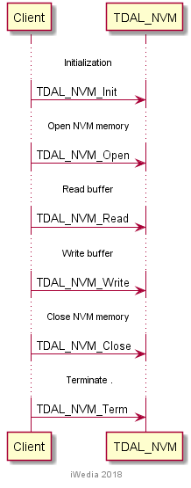

TDAL_NVM Macro/Define/Enum/Typedef/Structure Definitions

Enumeration Definitions

tTDAL_NVM_ErrorCode
This data type lists the different possible errors generated by TDAL_NVM module.
typedef enum
{
eTDAL_NVM_NO_ERROR, /* No Error returned */
eTDAL_NVM_NOT_DONE /* Nothing done */
}tTDAL_NVM_ErrorCode;

TDAL_NVM API Functions

TDAL_NVM_Init(-)
Prototype:
tTDAL_NVM_ErrorCode TDAL_NVM_Init (void);
Description:
This function initialises structures which describe and control the NVM.
Return value:
It returns eTDAL_NVM_NO_ERROR if initialization succeed.
Parameters:
None.
Comments:
None.

TDAL_NVM_Term(-)
Prototype:
tTDAL_NVM_ErrorCode TDAL_NVM_Term (void);
Description:
This function is used to terminate an instance of the driver opened by TDAL_NVM_Init().
Return value:
It returns eTDAL_NVM_NO_ERROR if termination succeed.
Parameters:
None.
Comments:
None.

TDAL_NVM_Open(-)
Prototype:
tTDAL_NVM_ErrorCode TDAL_NVM_Open(void);
Description:
This function allow the access to the NVM.
Return value:
It returns eTDAL_NVM_NO_ERROR if function succeed.
Parameters:
None
Comments:
None

TDAL_NVM_Close(-)
Prototype:
tTDAL_NVM_ErrorCode TDAL_NVM_Close(void);
Description:
This function closes access to the NVM. Any subsequent calls to TDAL_NVM_Read() or TDAL_NVM_Write() operations will require an new TDAL_NVM_Open() call.
Return value:
It returns eTDAL_NVM_NO_ERROR if function succeed.
Parameters:
None
Comments:
None

TDAL_NVM_Read(-)
Prototype:
uint32_t TDAL_NVM_Read
(
uint32_t Address,
uint32_t NumberToRead,
uint8_t* Buffer
);
Description:
The content of the NVM starting at Address and of length NumberToRead will be copied to Buffer.
The NumberToRead value is checked to ensure that the read attempt is not made beyond the end of the NVM.
Return value:
It returns the number of bytes that have been successfully read into the buffer. If the return value is 0, an error has occured.
Parameters:
Parameter | Type | Dir | Description
Address | uint32_t | In | Address offset to the NVM to be read
NumberToRead | uint32_t | In | Number of bytes to be read from the NVM
Buffer | uint8_t* | Out | Buffer where to copy the data read from the NVM
Comments:
None

TDAL_NVM_Write(-)
Prototype:
uint32_t TDAL_NVM_Write
(
uint32_t Address,
uint32_t NumberToWrite,
uint8_t* Buffer
);
Description:
The contents of the memory in Buffer and of length NumberToWrite will be copied to the NVM starting at Address.
Return value:
It returns the number of bytes that have been successfully written to the NVM. If the return value is 0, an error has occured.
Parameters:
Parameter | Type | Dir | Description
Address | uint32_t | In | Address offset to the NVM area to be written
NumberToWrite | uint32_t | In | Number of bytes to be written to the NVM area
Buffer | uint8_t* | In | Buffer from where to get the data
Comments:
None

Support for NON-NVM platforms
In case there is no support for non-volotile memory in chip, it must be emulated using existing flash memory.

Module TDAL_NVM must be implemented using additional spare flash block at most. Spare block is not accesable from TDAL_NVM API.

Requirements:
- Last 16 bytes of each physical block can be used to maintan NVM logic
- To user, NVM is continuous memory array
- Size of NVM is smaller then the physical size on flash
- One block will be dedicated as spare block to accomplish NVM
- Size of each block is reduced for size of header
Following picture gives more details. It is devided in three columns, depicting physical view, organization and user perspective. In Physical View column there are N+1 physical flash blocks used by NVM, where N blocks are actively used for reading, and one spare block will be used for write operation.
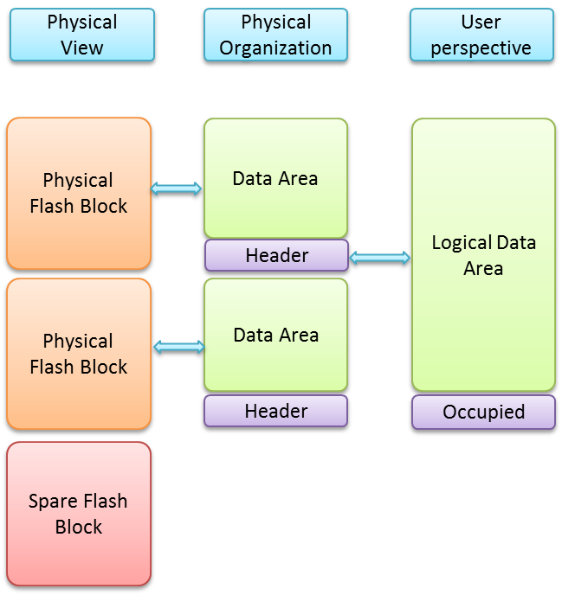
When write operation is required for logical block K (0<=K<=N-1), data will not be written to block where logical block K is stored but to spare block. This ensures that if write fails due to power cut, original block is still available. Upon write operation completion, spare block becomes logical block K. Previous physical block that stored old version of K block becomes spare block for next write operation.

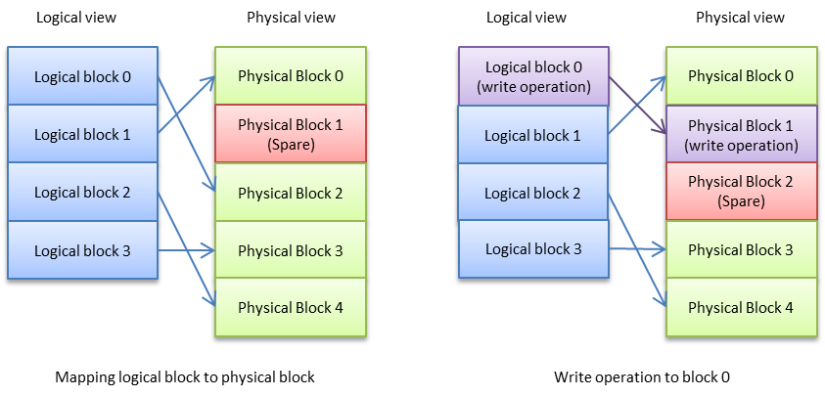

In order to maintain location of each logical block, each physical block contains a header, with information about logical block, version and CRC. In Physical Organization column can be seen that header is at the end of the physical block.
For user of TDAL_NVM API, memory is continuous (User perspective column), and addresses beyond logical Data area will be inaccesable. Data size will be calculated as:
NVM_Size = N*(PhysicalBlockSize – HeaderSize)

During NVM initialization, spare block must be found or selected in case NVM is clean, and all logical blocks must be mapped to physical blocks. Number of logical blocks in N and number of physical blocks is N+1 (additional spare block).
Header should contain magic number, version, block id, and CRC. Block Id maps physical block to logical block addressed by API, version gives information about latest block, in case there are 2 blocks with same block id, CRC is check sum of data in the block.
Note: In case of using additional libraries for implementation, physical blocks and addressing ranges must be configurable from inside of TDAL_NVM module. Hard-coding addresses inside SDK or additional libraries are not permitted. It is necessary to support different memory maps from TDAL_NVM module.

